Exercise 2: Verifying Interactions

Scenario: You need to ensure that a method is called with specific arguments.

Steps:

1. Create a mock object.

2. Call the method with specific arguments.

3. Verify the interaction.

**Solution code:**

1. Using our existing ***ExternalApi*** and ***MyService*** classes which were created during Exercise-1.
2. **Create** a **new test method** in **MyServiceTest** to:

a.✅ Create a mock object.

b.✅ Call a method on MyService that depends on that mock.

c.✅ Use verify() to check the interaction.

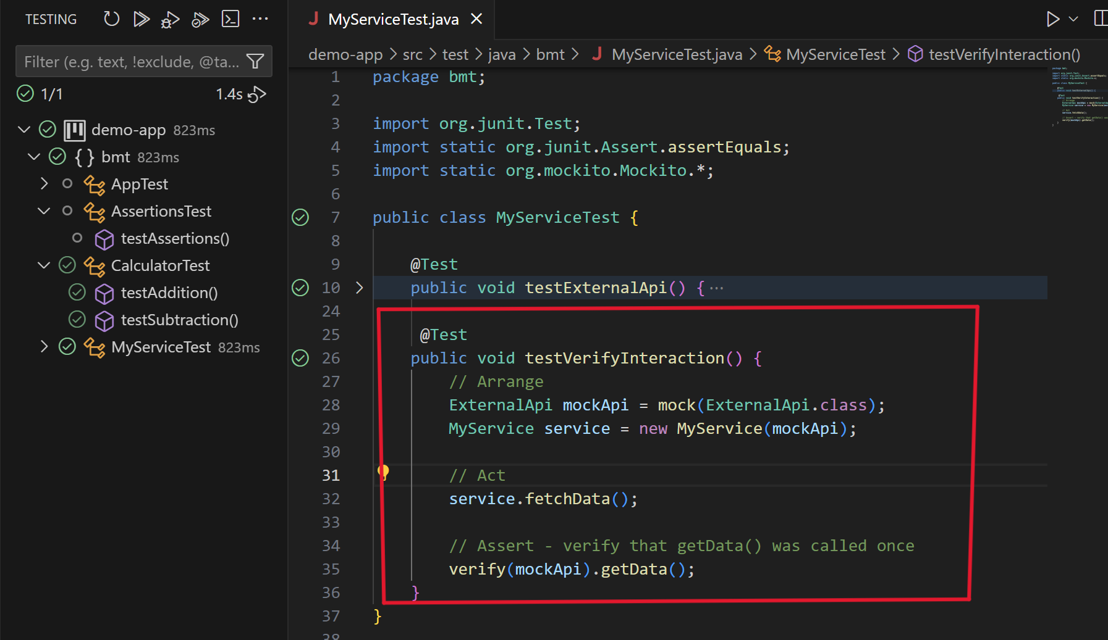

▪ Here the ***green-tick*** represent the ***successful run of test-cases(1/1) using Mockito dependency***.

*********************************************************************************************